**Hypothesis tests and z-scores**

Hi, I'm James. Welcome to this course on hypothesis testing in Python. To start, let's look at a real-world example where a hypothesis test was crucial in a decision-making process.

**A/B testing**

In 2013, Electronic Arts, or EA, launched a video game called SimCity 5. Leading up to its release, they wanted to increase pre-order sales. They used an experimental design technique called A/B testing, which has roots in hypothesis testing, to test different advertising scenarios and see which improved sales the most. Website visitors were split into a control group and a treatment group. Each group saw a different version of the game's pre-order sales page.

1. 1 Image credit: "Electronic Arts" by majaX1 CC BY-NC-SA 2.0

**Retail webpage A/B test**

Here's each version of the SimCity 5 pre-order page. The control group saw the version with a banner advertising money off their next purchase with each pre-order. The treatment group saw the version without the banner. EA compared the percentage of checkouts for the two groups to see which performed best. Our naive guess would be that the advertisement increased pre-order sales.

**A/B test results**

The results of the A/B test were surprising. The treatment page without the advertisement resulted in 43 percent higher sales than the control page with the advert. The experiment proved that our intuition that more discount adverts would result in more sales was false. We might ask ourselves, was the 43 percent difference a meaningful difference between the control and treatment groups, or was it just random chance? To get this answer, we'd need the original dataset from EA, which isn't publicly available. However, the method to answering this question of significance would involve techniques from both the Sampling in Python course and from this course.

**Stack Overflow Developer Survey 2020**

Each year, Stack Overflow surveys its users, who are primarily software developers, about themselves, how they use Stack Overflow, their work, and the development tools they use. In this course, we'll look at a subset of the survey responses from users who identified as Data Scientists.

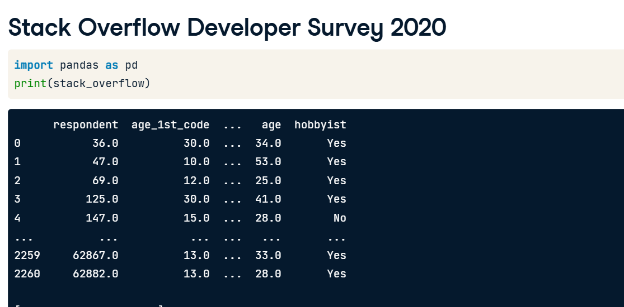

**Hypothesizing about the mean**

Let's hypothesize that the mean annual compensation of the population of data scientists is 110,000 dollars. We can initially examine the mean annual compensation from the sample survey data. Annual compensation, converted to dollars, is stored in the converted_comp column. The sample mean is a type of point estimate, which is another name for a summary statistic. We can calculate it with pandas using the dot-mean method on the converted_comp Series. The result is different from our hypothesis, but is it meaningfully different?

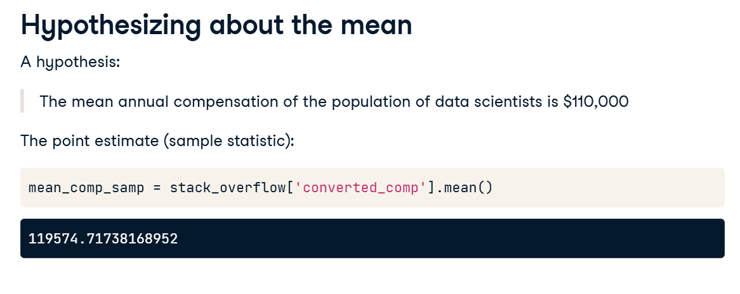

**Generating a bootstrap distribution**

To answer this, we need to generate a bootstrap distribution of sample means. This is done by resampling the dataset, calculating the sample mean for that resample, then repeating those steps to create a list of sample means.

1. 1 Bootstrap distributions are taught in Chapter 4 of Sampling in Python

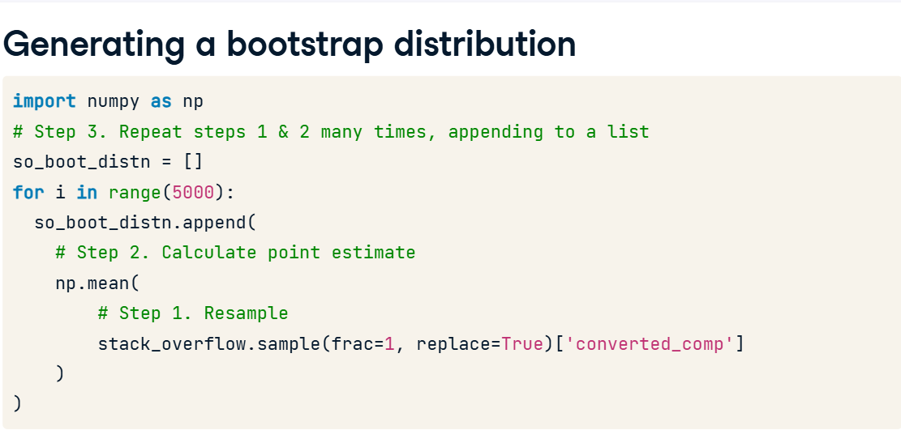

**Visualizing the bootstrap distribution**

Here's a histogram of the bootstrap distribution. Its bell shape means that it's roughly normally distributed. Notice that 110,000 is on the left of the distribution.

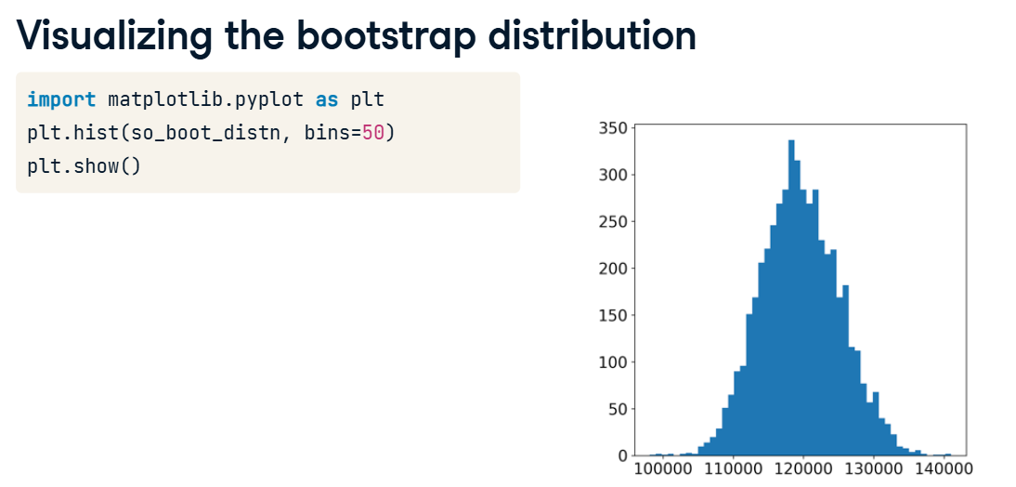

**Standard error**

Recall that the standard deviation of the sample statistics in the bootstrap distribution estimates the standard error of the statistic.

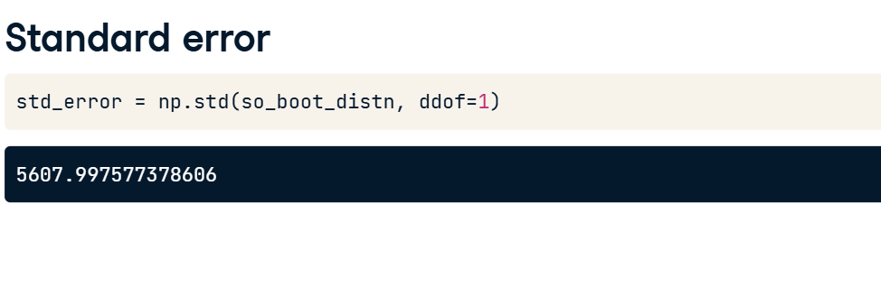

**z-scores**

Since variables have arbitrary units and ranges, before we test our hypothesis, we need to standardize the values. A common way of standardizing values is to subtract the mean, and divide by the standard deviation. For hypothesis testing, we use a variation where we take the sample statistic, subtract the hypothesized parameter value, and divide by the standard error. The result is called a z-score.

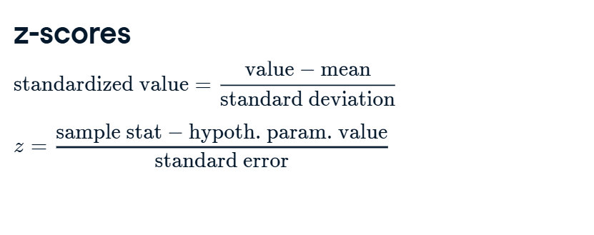

Here are the values we calculated earlier. The sample mean annual compensation for data scientists of around 120,000 dollars, minus the hypothesized compensation of 110,000, divided by the standard error gives a z-score of one-point-seven-zero-seven.

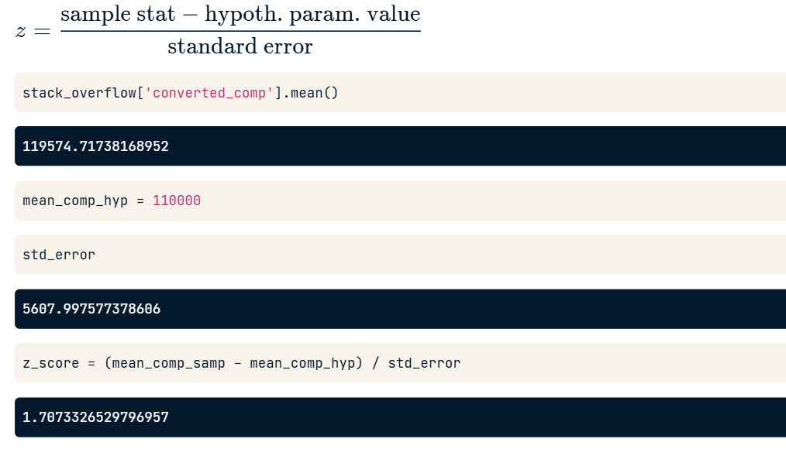

**Testing the hypothesis**

Is that a big or small number? Determining that is the goal of this course.

In particular, we can now state one of the uses of hypothesis testing: determining whether a sample statistic is close to or far away from an expected value.

**Standard normal (z) distribution**

One final thing. Here's a plot of the probability density function for the standard normal distribution, which is a normal distribution with mean of zero and standard deviation of one. It's often called the z-distribution, and z-scores are related to this distribution. We'll encounter the z-distribution throughout this course.

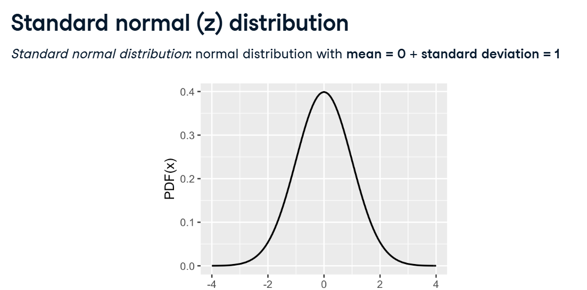

**p-values**

Hypothesis tests are like criminal trials.

**2. Criminal trials**

00:03 - 00:27

There are two possible true states: the defendant either committed the crime, or didn't. There are also two possible outcomes: a guilty or not guilty verdict. The initial assumption is that the defendant is not guilty, and the prosecution team must present evidence beyond a reasonable doubt that the defendant committed the crime for a guilty verdict to be given.

**3. Age of first programming experience**

00:27 - 01:01

Let's return to the Stack Overflow survey. The age_first_code_cut variable classifies when the user began programming. If they were 14 or older, they are classified as adult; otherwise, child. Suppose previous research suggests that 35 percent of software developers programmed as children. This raises a question answerable with our dataset. Does our sample provide evidence that a greater proportion of data scientists started programming as children?

**4. Definitions**

01:01 - 01:54

Let's specify some definitions. A hypothesis is a statement about a population parameter. We don't know the true value of this population parameter; we can only make inferences about it from the data. Hypothesis tests compare two competing hypotheses. These two hypotheses are the null hypothesis, representing the existing idea, and the alternative hypothesis, representing a new idea that challenges the existing one. They are denoted H-naught and H-A, respectively. Here, the null hypothesis is that the proportion of data scientists that started programming as children follows the research on software developers, at 35 percent. The alternative hypothesis is that the percentage is greater than 35.

1. 1 "Naught" is British English for "zero". For historical reasons, "H-naught" is the international convention for pronouncing the null hypothesis.

**5. Criminal trials vs. hypothesis testing**

01:54 - 02:47

Returning to our criminal trial comparison, the defendant can be either guilty or not guilty, and likewise, only one of the hypotheses can be true. Initially, the defendant is assumed to be not guilty and, similarly, we initially assume that the null hypothesis is true. This only changes if the sample provides enough evidence to reject it. Rather than saying we accept the alternative hypothesis, it is convention to refer to rejecting the null hypothesis, or failing to reject the null hypothesis. If the evidence is "beyond a reasonable doubt" that the defendant committed the crime, then a "guilty" verdict is given. The hypothesis testing equivalent of "beyond a reasonable doubt" is known as the significance level - more on this later in the chapter.

**6. One-tailed and two-tailed tests**

02:47 - 03:45

The tails of a distribution are the left and right edges of its PDF. Hypothesis tests determine whether the sample statistics lie in the tails of the null distribution, which is the distribution of the statistic if the null hypothesis was true. There are three types of tests, and the phrasing of the alternative hypothesis determines which type we should use. If we are checking for a difference compared to a hypothesized value, we look for extreme values in either tail and perform a two-tailed test. If the alternative hypothesis uses language like "less" or "fewer", we perform a left-tailed test. Words like "greater" or "exceeds" correspond to a right-tailed test. For the Stack Overflow hypothesis test, we need a right-tailed test since we are looking for extreme values in the right tail.

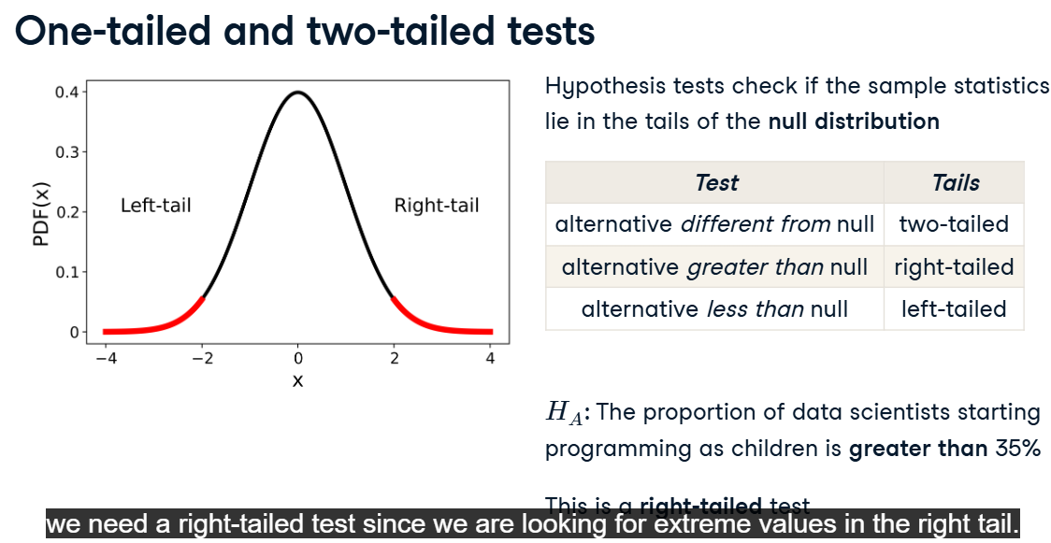

**7. p-values**

03:45 - 04:24

p-values measure the strength of support for the null hypothesis, or in other words, they measure the probability of obtaining a result, assuming the null hypothesis is true. Large p-values mean our statistic is producing a result that is likely not in a tail of our null distribution, and chance could be a good explanation for the result. Small p-values mean our statistic is producing a result likely in the tail of our null distribution. Because p-values are probabilities, they are always between zero and one.

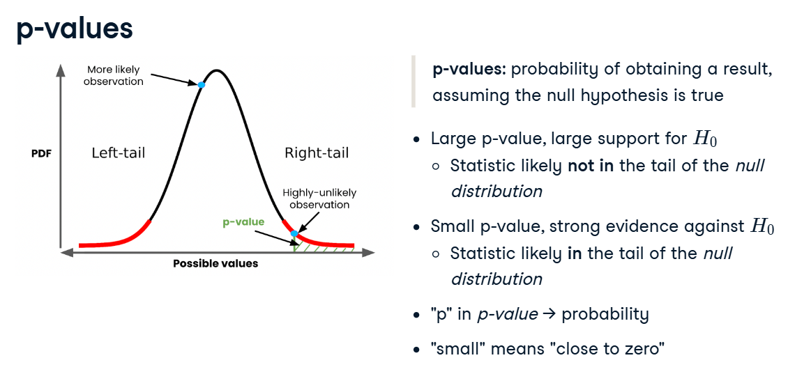

**8. Calculating the z-score**

04:24 - 04:55

To calculate the p-value, we must first calculate the z-score. We calculate the sample statistic, in this case the proportion of data scientists who started programming as children. The hypothesized value from the null hypothesis is 35 percent. We get the standard error from the standard deviation of the bootstrap distribution, and the z-score is the difference between the proportions, divided by the standard error.

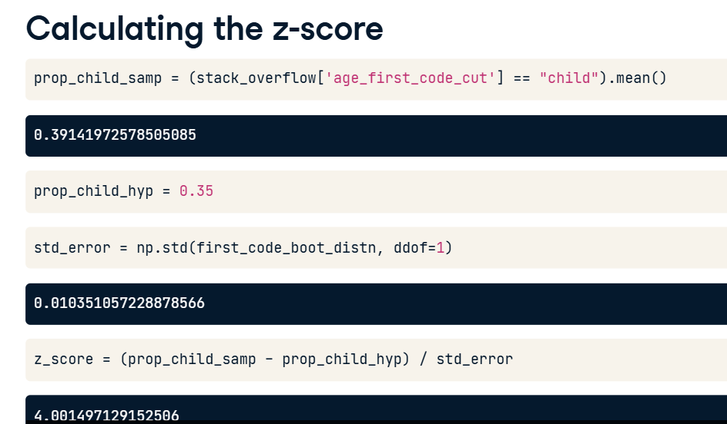

**9. Calculating the p-value**

04:55 - 05:21

We pass the z-score to the standard normal CDF, norm-dot-cdf, from scipy-dot-stats with the default values of mean zero and standard deviation of one. As we're performing a right-tail test, not a left-tail test, the p-value is calculated by taking one minus the norm-dot-cdf result. The p-value is three out of 100,000.

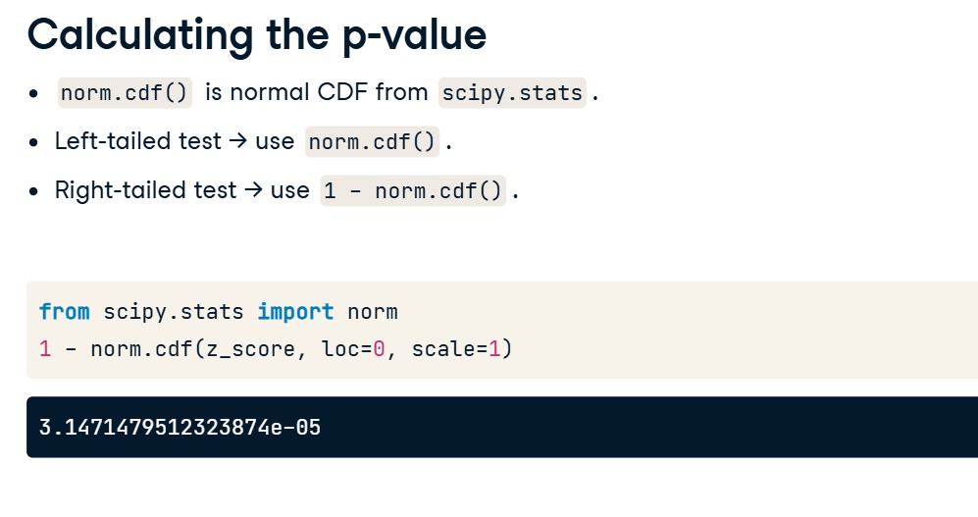

**Statistical significance**

Last time, we introduced p-values.

**2. p-value recap**

00:03 - 00:30

p-values quantify how much evidence there is for the null hypothesis. Large p-values indicate a lack of evidence for the alternative hypothesis, sticking with the assumed null hypothesis instead. Small p-values make us doubt this original assumption in favor of the alternative hypothesis. What defines the cutoff point between a small p-value and a large one?

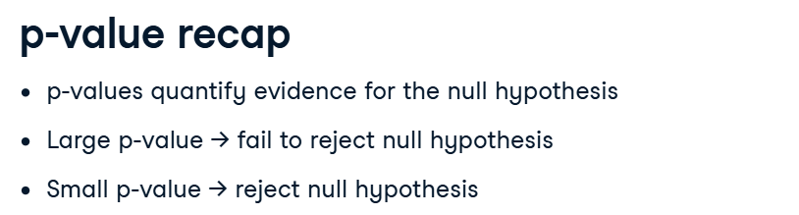

**3. Significance level**

The cutoff point is known as the significance level, and is denoted alpha. The appropriate significance level depends on the dataset and the discipline worked in. Five percent is the most common choice, but ten percent and one percent are also popular. The significance level gives us a decision process for which hypothesis to support. If the p-value is less than or equal to alpha, we reject the null hypothesis. Otherwise, we fail to reject it. It's important that we decide what the appropriate significance level should be before we run our test. Otherwise, there is a temptation to decide on a significance level that lets us choose the hypothesis we want.

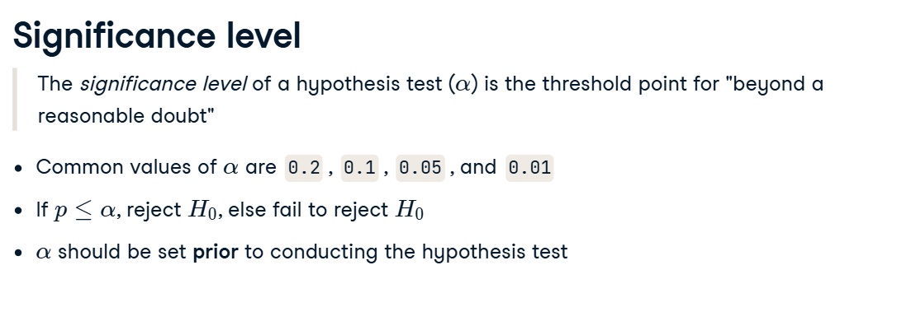

**4. Calculating the p-value**

The workflow starts with setting the significance level, in this case point-zero-five. Next, we calculate the sample mean and assign the hypothesized mean. For the z-score, we also need the standard error, which we obtain from the bootstrap distribution. Then we calculate the z-score using the sample mean, hypothesized mean, and standard error, and use the standard normal CDF to get the p-value.

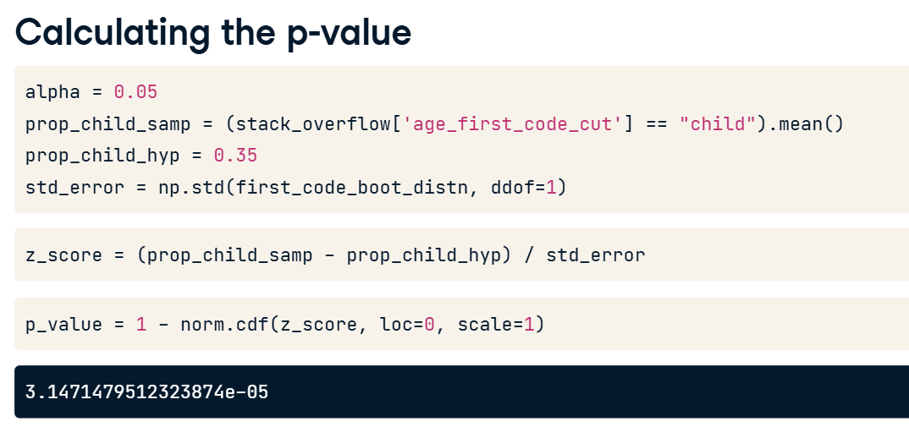

**5. Making a decision**

In this case, the p-value of three times ten to the minus five is less than or equal to point-zero-five, so we reject the null hypothesis. We have strong evidence for the alternative hypothesis that the proportion of data scientists that started programming as children is greater than 35 percent.

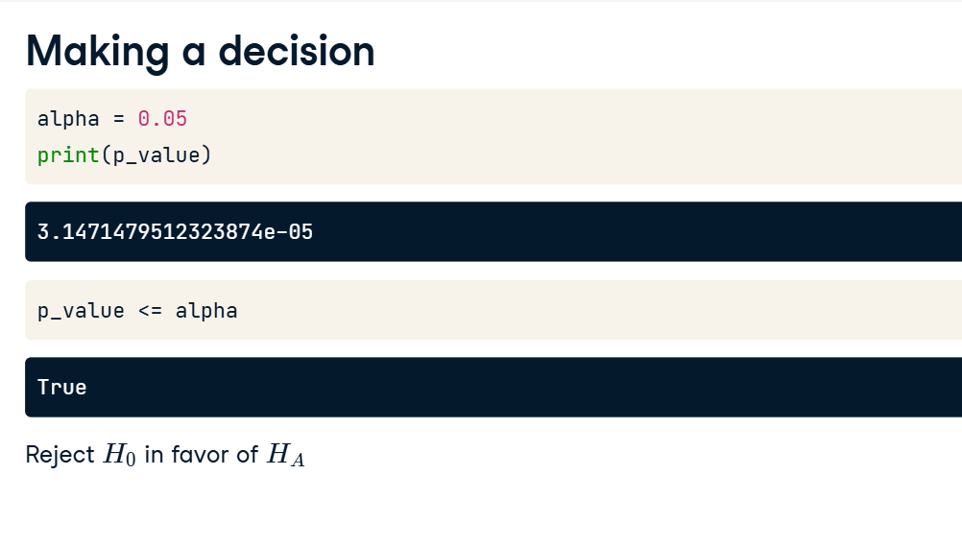

**6. Confidence intervals**

To get a sense of the potential values of the population parameter, it's common to choose a confidence interval level of one minus the significance level. For a significance level of point-zero-five, we'd use a 95 percent confidence interval. Here's the calculation using the quantile method. The interval provides a range of plausible values for the population proportion of data scientists that programmed as children.

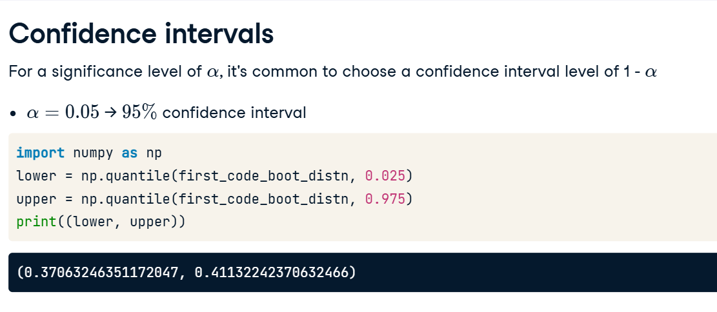

**7. Types of errors**

02:37 - 03:32

Returning to the criminal trial analogy, there are two possible truth states and two possible test outcomes, amounting to four combinations. Two of these indicate that the verdict was correct. If the defendant didn't commit the crime, but the verdict was guilty, they are wrongfully convicted. If the defendant committed the crime, but the verdict was not guilty, they got away with it. These are both errors in justice. Similarly, for hypothesis testing, there are two ways to get it right, and two types of error. If we support the alternative hypothesis when the null hypothesis was correct, we made a false positive error. If we support the null hypothesis when the alternative hypothesis was correct, we made a false negative error. These errors are sometimes known as type one and type two errors, respectively.

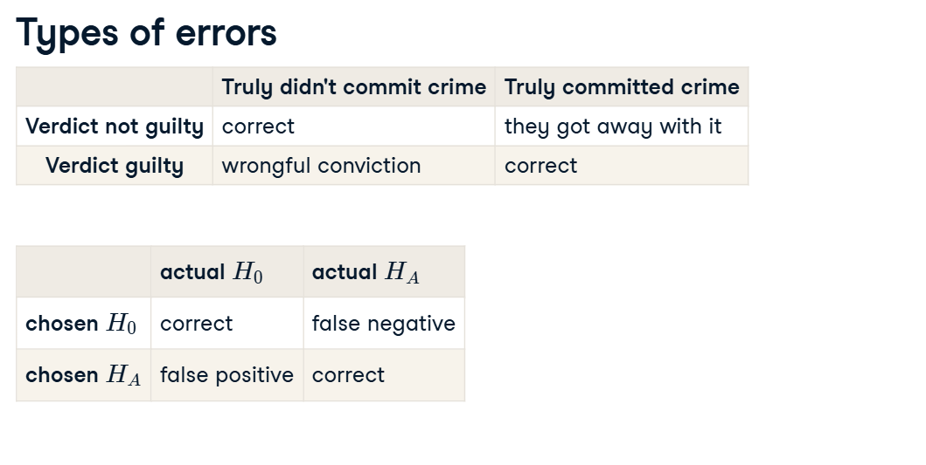

**8. Possible errors in our example**

03:32 - 04:04

In the case of data scientists coding as children, if we had a p-value less than or equal to the significance level, and rejected the null hypothesis, it's possible we made a false positive error. Although we thought data scientists started coding as children at a higher rate, it may not be true in the whole population. Conversely, if the p-value was greater than the significance level, and we failed to reject the null hypothesis, it's possible we made a false negative error.

